**Ricardo Porro Hidalgo (1925, Camaguey – 2014, Paris), Architect, Artist, Urbanist**

Best known for his involvement in the design of theNational School of Art(1961-1965), Ricardo Porro’s work in Cuba marks a brief-lived yet spiritually lingering venture into a figurative modernism. Abandoning the rational and functional tendencies of his early training, Porro embarked on a project beginning in the late 1950’s that sought to find a formal means of expression that challenged the abstract modernism of the period by incorporating gestures of an often romantic symbolism. Rising to prominence in the local design community at a time when *cubanidad* (the cultural spirit and expression of Cuban-ness) was a matter of impassioned debate, Porro challenged the accepted notion of Spanish-colonial primacy in the modern movement’s historical yearnings, advocating a *criollo* (culturally mixed) artistic tendency. In addition, he became a vociferous proponent for the cultivation of Cuba’s “black tradition,” a stylistic notion present in the Afro-Cuban vernacular as well as the island’s artistic vanguard. As Porro and the unfinished Schools of Art fell out of favor with the Revolution, the young architect had no choice but to leave his native country in order to continue practicing his art. He entered into exile in 1967 when he left for Paris. He continues to design, now in partnership with Renaud de la Noue.

Ricardo Porro was born into a family of modest privilege in the city of Camaguey. His formal education in architecture began at the University of Havana during a period of reform incited by the students and sympathetic members of the faculty. In 1947 he took part, along with other students, in the famed *Quema de los Vignola* – an act of pedagogical rebellion where copies of Giacomo Barozzi da Vignola’s *Regola delli cinque ordini d'architettura* (Rules of the Five Orders of Architecture, 1562) were stolen from the university’s library and publically burned in the school’s courtyard. After receiving his degree in 1949, he spent two years at the Institute of Urbanism at the Sorbonne in Paris. His sojourn in Europe left an indelible cultural impression. While in Paris he befriended the reknowned Cuban painter Wilfredo Lam. Porro credits the development of his interests in Afro-Cuban culture and artistic practice as well as his early political formation as a Marxist (a position that he now refutes) to this early contact. His time in the Parisian capital also afforded him contact with Picasso in the artist’s apartment and studio, and inevitably a private audience with Le Corbusier who offered him a position in his office. Although his tour of the office afforded him an intimate look at the ongoing design process of the chapel of Notre Dame du Haut at Ronchamp (completed in 1955) – a brief, poignant experience that Porro claimed to be “real education,” the working environment and formation of the Swiss architect’s employees did not suit him nor his creative aspirations. Nonetheless, before leaving Europe, Porro attended a studio-based course in Venice organized by the CIAM (Congrés International d’Architecture Moderne). Taught by Le Corbusier, Giulio Carlo Argan, Ignacio Gardella, Ernesto Rogers, Carlo Scarpa, and Bruno Zevi, the project initially focused on the urban rationalization of the medieval city. The influence of Rogers instead imparted on Porro ideas concerning architectural tradition and continuity.

Porro’s work in Cuba is not extensive. His earliest work reflected a rationalist tendency, visible in his Armenteros House (1949) and House of Waldo García (1953). The embrace of a more expressive formalism did not occur until the completion of his House of Cristina Abad (1954), which makes extensive use of *vitrales* (stained glass windows) in reference to the Spanish colonial use of the material to filter the tropical sun’s penetration into their architectural interiors. In an act of opposition to the Iberian traditions represented in that house and much of the Cuban architecture of the time, he published the provocative article “Sentido de la Tradición” (*Sense of Tradition*) in 1957. In that text he argues for the primacy of local tradition, in particular the hybridization of Black African and European social and cultural forms, in the creation of a truly Cuban architecture. This theoretical shift inspired an increasingly organic means of expression well exhibited in his boldly dynamic House of Timothy James Ennis (1957).

During this period Porro also participates in urbanist projects, working on the development of East Havana with Cuban architect Miguel Gaston and the Italian architect Franco Albini. His involvement in activities against Cuban Dictator Gen. Fulgencio Batista cut these activities short, however, as he was forced to depart to Venezuela in 1958. While there, he found work in the office of Carlos Raul Villanueva (1900-1975), the architect of the famous Ciudad Universitaria (1944-1970). He remained there, working on urban development works until the success of the Cuban Revolution brought him back to the island in 1960.

He received the commission for the art schools, inviting Vittorio Garatti (whom he met in Villanueva’s office) and Roberto Gottardi to join him. The former was responsible for the School of Dramatic Arts and the Latter for the School of Music and the School of Ballet. Porro designed the School of Plastic Arts and the School of Modern Dance. All five schools reflected the material shortages imposed by the revolution and the United States-imposed embargo. Local materials had to be utilized, which was a partial rationale for the use of brick and clay tile Catalan vaults in the complex’s construction. The organic and expressive composition of the schools fell foul with two growing trends within Cuba’s revolutionary culture and its Ministry of Construction (MICONS): the first was the rationalization of structure and material through methods of prefabrication, both native and imported from other Soviet countries; the second was the discouragement of individual expression in design in favor of collaborative practice. This trend was visible at the 1963 Congress of the *Union Internationale des Architects* (UIA) held in Havana and its focus on the architecture of “underdeveloped” countries. Although received warmly by the participants at the congress, the schools barely received mention in the publication submitted by the Cuban delegation. Work halted soon afterwards, and Porro left the country in 1967.

Porro has enjoyed success in exile as a designer. The Center for the Arts in Vaduz, Liechtenstein (1974) marks his continued interests in the local traditions of the areas in which his architecture is situated, drawing inspiration from German philosophy and art by referencing, in his signature figurative fashion, the work of Nietzche and the operas of Wagner. Since 1994, his collaboration with Renaud de la Noue has offered Porro a steady flow of work entirely devoted to projects of social import throughout France. Important buildings completed by this partnership are the Collège Elsa Triolet (Saint Denis, 1990), Collège des Explorateurs (Cergy Pontoise, 1996), and the Bâtiment de Psychiatrie adulte (Meulan Les Mureaux, 2008-2011). Ricardo Porro continues to practice art and architecture in Paris.

Further Reading:

Loomis, John A. (1999) *Revolution of Forms: Cuba’s Forgotten Art Schools,* New

York: Princeton Architectural Press.

Rodríguez, Eduardo Luís (1998) *La Habana: Arquitectura del Siglo XX,* Barcelona:

Blume.

Porro, Ricardo (1994) *Ricardo Porro: Architect*, Klagenfurt: Ritter.

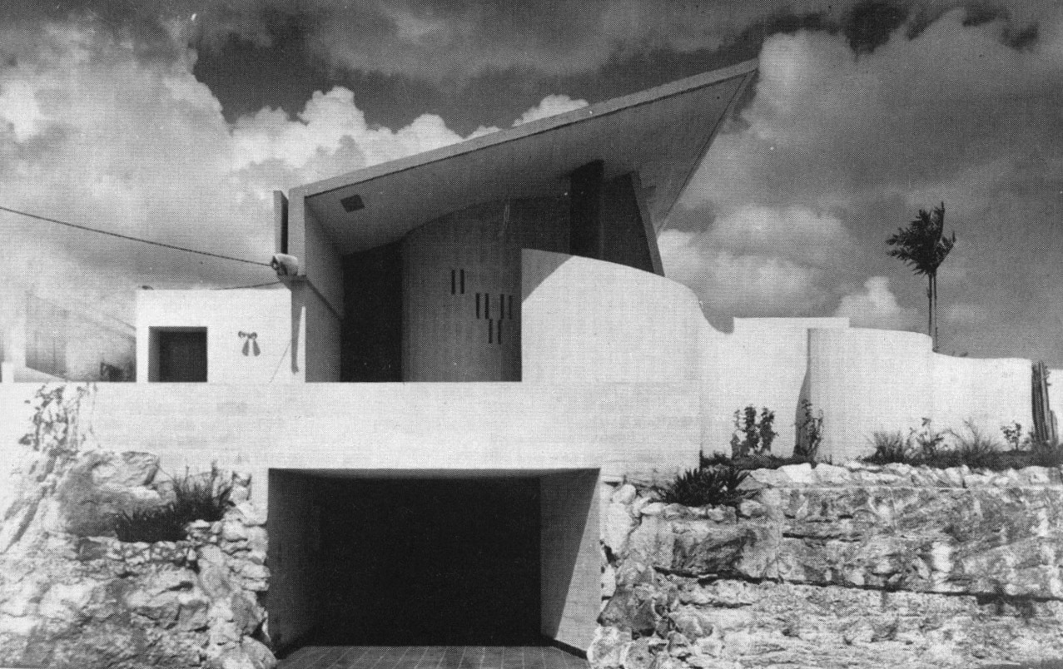

House of Timothy James Ennis, 1957. (Image in *Havana Guide,* pg 163. Author does not credit source – likely from *Arquitectura*)

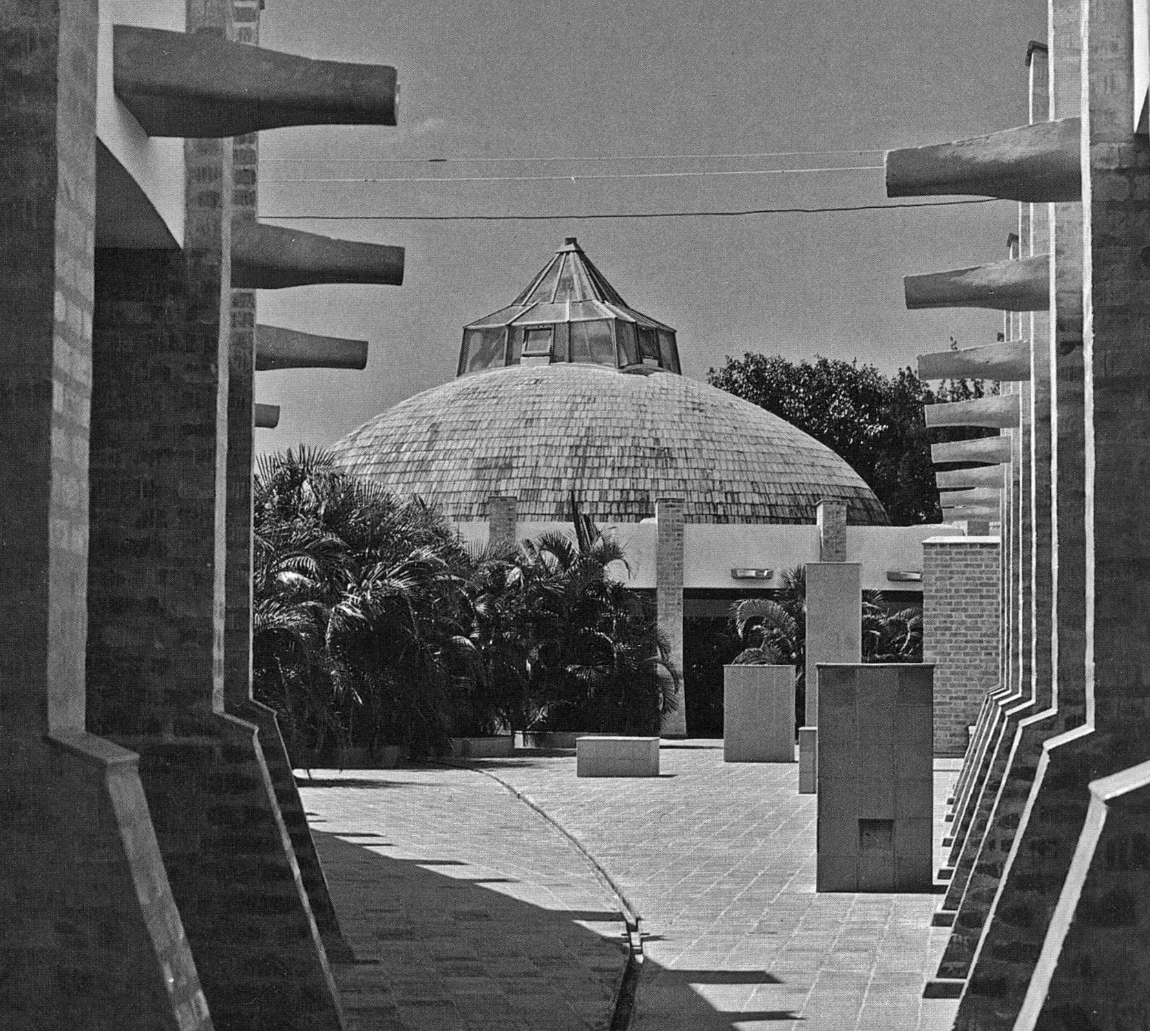

School of Plastic Arts, view of studio between colonades. (Image in *Revolution of Forms,* pg 57. Image by Paolo Gasparini)

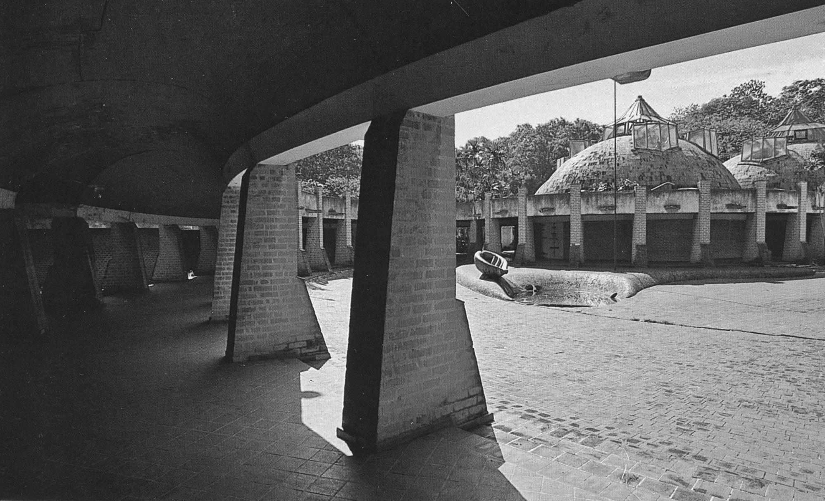

School of Plastic Arts, view of principal courtyard with “papaya” fountain. (Image in *La Habana: Arquitectura del Siglo XX,* pg 310. Image by Pepe Navaro)

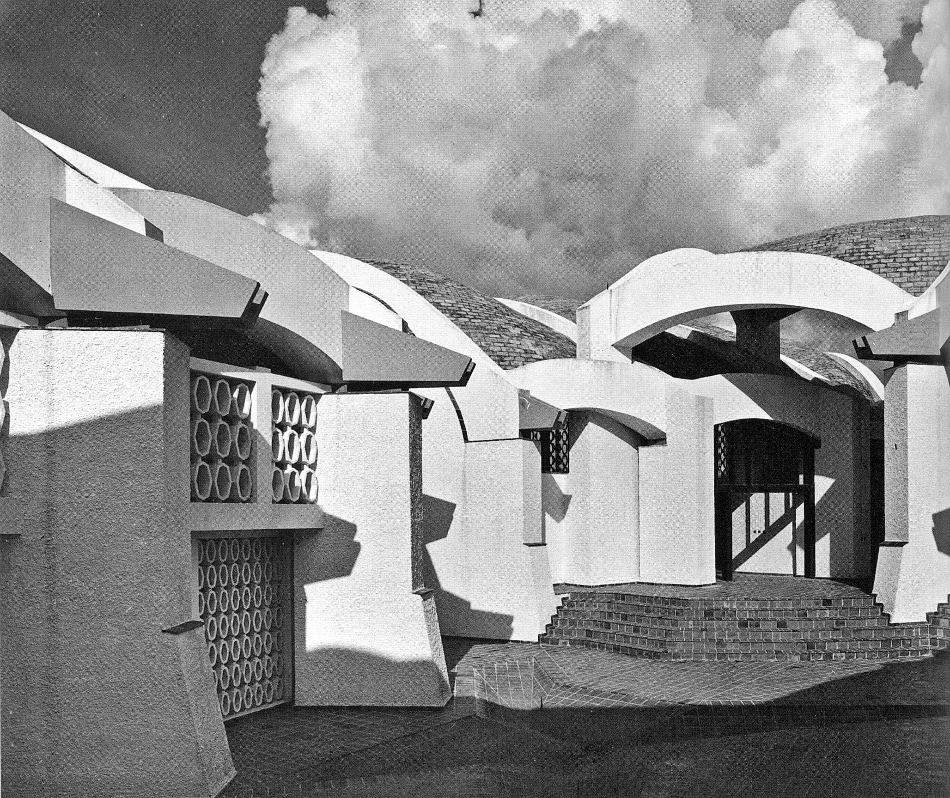

School of Modern Dance, view of entry courtyard. (Image in *Revolution of Forms,* pg 50. Image by Paolo Gasparini)

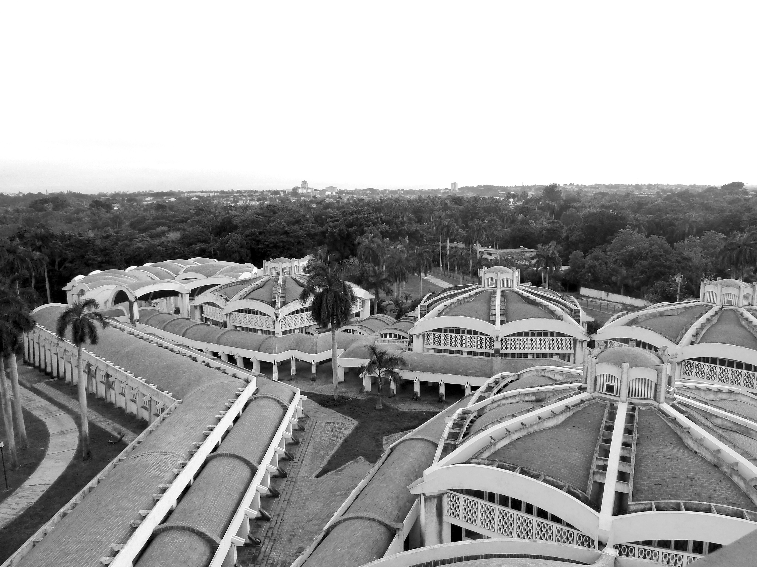

Aerial view of School of Modern Dance. (Photo by Author, Albert José-Antonio López)